OOPs Concepts
- Encapsulation Security / To avoid unwanted data access/modification

- Make/declare variables private
- Provide public getter and setter (control access)

- Inheritance

- Polymorphism
- Abstraction

Inheritance Means Code reusability
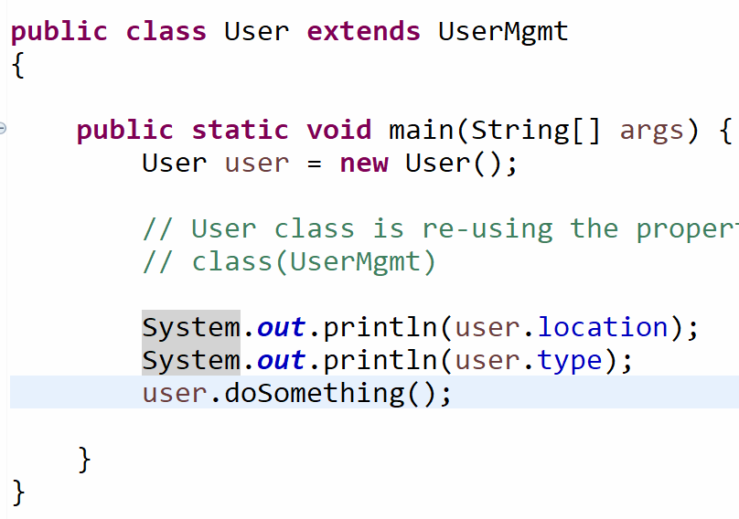
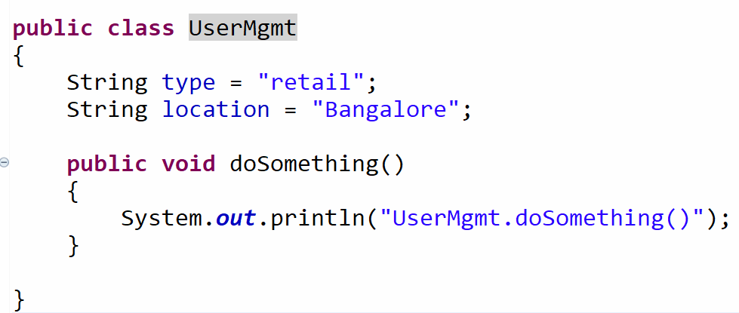

Electronic Item is a type of Product

Develop a program and achieve inheritance
- Product
- ClothingProducts
- MensProduct
- WomensProduct

